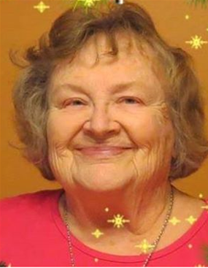
TAKEAWAYS BY DR. MARILYN LAKE, Children’s Author – SWG September Speaker
September 26, 2020

Noted children’s book author, Dr. Marilyn Lake, offers these tips:
- Write out your complete story without revision in the first round. Don’t try to go back to edit as you write. Capture all your ideas before they escape.
- The best way to tell a true story is through creative writing. Dramatize and embellish. Use lots of dialogue.
- Make every single word count – especially in a children’s book where you have limited words to work with.
- Write simply so a 5th grader (10-year-old) can understand. Use concrete words instead of abstract words.
- For children – use rhythm, repetition, rhyme.
- Appeal to the senses in description – see, taste, hear, smell, touch. Help the reader ‘experience’ your story!
RESOURCES RECOMMENDED:
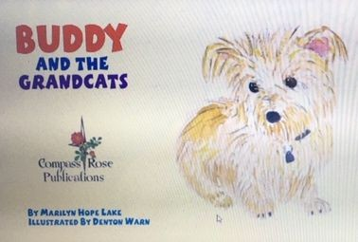
Writeforkids.org; Children’s Book Insider (website & FB)
“How to Write and Sell Children’s Books” by Jean Karl
Ten visitors, the Boonslick Creative Writers’ Group of Boonville, MO, joined our August meeting. Other SWG members participated from Republic, Bolivar, Waynesville, Columbia, Stockton, Buffalo, Willard, Fair Grove, Nixa, and Springfield. Join us September 26!

